Information Sheet February 2017

Adjustable segmented heavy duty top tube, instructions for installation
The Top Tubes are now made with a floating section on each end of the tube. This allows for the tube ends to be properly aligned with the edge of the blind to allow the blind to roll up evenly.
To install using these tubes you proceed as per normal installation and when all tracks are fixed in position, unwind the blind fully to expose the Top Tube and then move the unattached segment of tube at each end of the Top Tube to line up as per the diagram below.
The edge splines on the blind will now overhang the larger tube. Make sure the spline overhang is the same on both sides, by moving one of the sliders. Raise the blind slowly and check that the bottom bar is close to level when it reaches the top stops.

Adjustable end tube
Adjustable end tube

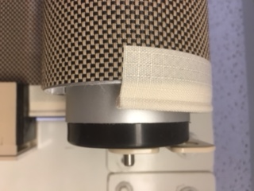
Side Spline
10 mm
10 mm

