SOMFY Override Motor: How To Install
SOMFY is well known as a world leader in tubular motor technology and have an advanced product range. This information page explains how to install the Somfy override system, and how to set the UP - DOWN limits. Your roller shutter comes fully assembled, all that is required is to fit the Cardan, and set the limit switch, which is explained below.
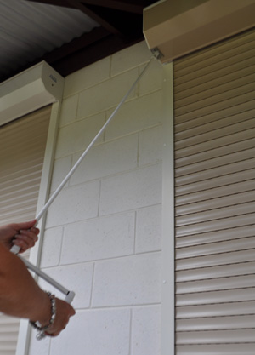 | This system operates when the power is out  The Somfy manual override system, allows your roller shutter to be fully operational, in the event of a power outage. This system is highly recommended for our Cyclone and our Security roller shutters.  The Security roller shutter has a bush fire rating of BAL 40, making the Somfy override motor a must-have feature.  The Somfy override system can also be used with our Domestic and Commercial roller shutters. This eliminates the problem of power outages when your roller shutter must be operational, even if the power is out.

How to Install and set the Limit Switch

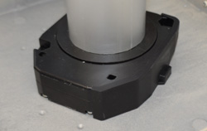 | Remove the limit switch cover | 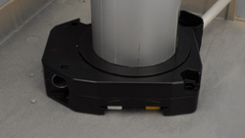
This cover can be removed after the Somfy motor has been hard wired by a qualified electrician. You can then fully lower the curtain of the roller shutter, but you must stop the curtain at the fully down position, with control switch supplied. The limit setting have not been set. How to set the limits is described below. With the curtain lowered you will then be able to see this limit setting cover.

Setting the Up and Down limits
With both buttons depressed, switch on the power supply. You can now check the up and down movement of the curtain at the control point. If the direction of movement is correct you can now move on to adjusting the stop limits. If the curtain is moving in the wrong direction to the control point's indicator of direction, turn the power off, and reverse the brown wire and black wire at the control point.
You are now ready the set the up and down limits, these limit setting are the same as the standard somfy motor which can be found at the link below.
Electric-Setting the up and down stop limits
Caution! Never operate the roller shutter by the control point, while using the override system. You must switch off the power supply first.

Fitting the Cardan
We can supply two types of fittings, the Invisible Cardan, or the Double Cardan with eye outlet, both types can be viewed at the bottom of this page.
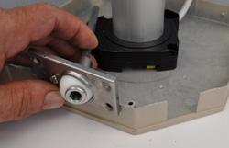 | Cut out the endplate | 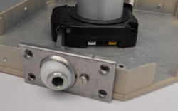
The endplate, and head box cover, will need a section cut out to receive the cardan. This is shown in the images above and below.
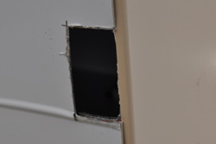 | Cut out head box cover | 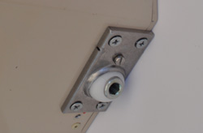
With the cut outs complete, and the cardan fitted, your override system is operational.
Caution! Never operate the roller shutter by the control point, while using the override system. You must switch off the power supply first.
Invisible Cardan  The invisible cardan will open and close your shutter when the power is out. This system is operated with a 1250mm crank shaft with handle, that is fitted with a 7mm hexagonal shaft. | 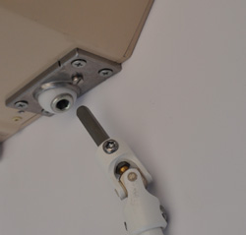

Double Cardan with Eye Outlet  The double cardan with eye outlet will open and close your shutter when the power is out. This system is operated with a 1250mm crank shaft with handle, that is fitted with a hook at the end of the shaft, as shown in the picture on the right. | 